Customer Journey Map

Scenario:
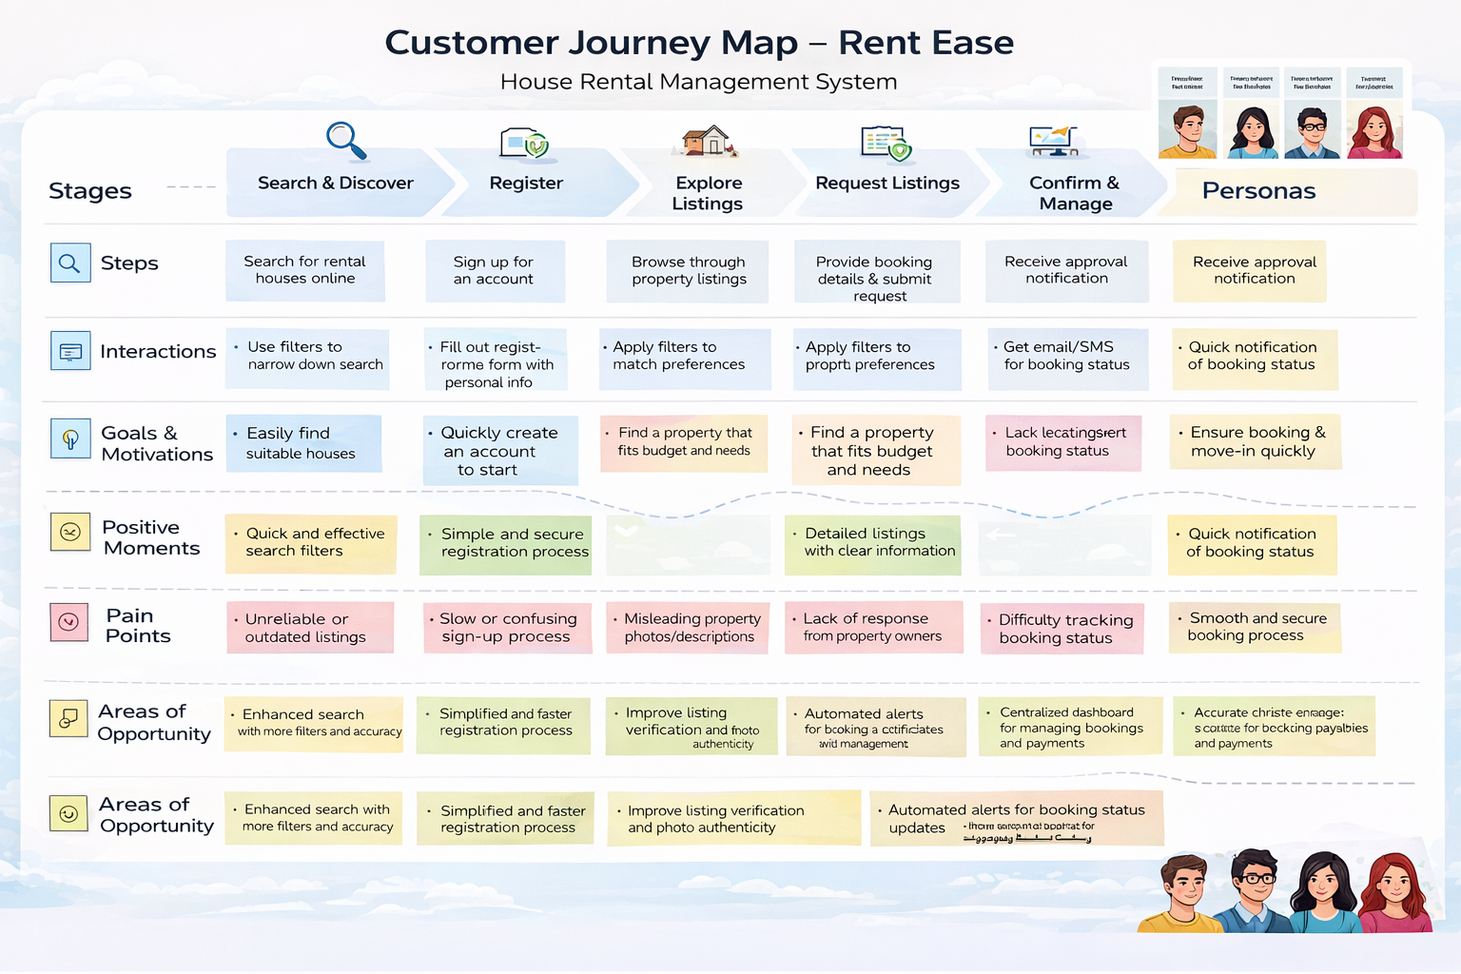
A renter or property owner uses the Rent Ease web application to search for rental houses, list properties, and manage bookings through a centralized digital platform.

Customer Journey Description
The customer journey begins when the user discovers the Rent Ease application through online advertisements, social media platforms, college groups, or word-of-mouth recommendations. The user becomes interested due to the need for a reliable and transparent house rental solution.
Next, the user opens the Rent Ease web application using a browser and lands on the home page. The interface provides clear navigation options for login, registration, and property browsing, making it easy for first-time users to proceed.
After logging in, the user browses available rental properties or, in the case of a property owner, accesses the option to add a new property. Renters can view property details such as location, price, and availability.
The user then interacts with the system by either submitting a booking request (renter) or managing property listings and booking requests (owner). The backend processes these actions securely and updates the database accordingly.
Once processed, the user views the booking status or property updates. Renters can see confirmation or rejection of their requests, while owners can track tenant interest and property availability.
The journey continues as users manage or repeat actions, such as booking another property, updating listings, or logging out after successful interaction.

Positive Moments
- Easy navigation and simple user interface
- Clear property listings with essential details
- Centralized booking and management system
- Reduced dependency on brokers

Negative Moments
- Limited features in initial usage
- Waiting time for booking approval
- No instant communication between renter and owner

Opportunities for Improvement
- Add real-time notifications for booking updates
- Integrate chat functionality between users
- Include online payment options
- Develop a mobile application version

